

**FALL 2018**

**(New Castle to Parachute)**

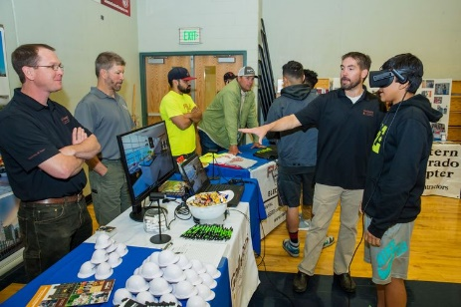 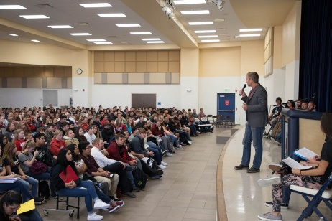 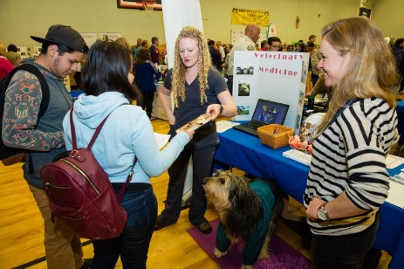

**“Career Makers” Invite You to Explore Your Future**

**Rifle High School, Rifle**

**Wednesday, October 24, 2018**

**8:00 am to 8:45 am** Set up (Gymnasium)

*Ready to go by 9:00 am*

**9:00 am to 1:00 pm** Career Expo (High School/ Gymnasiums)

*Business Professionals will be at Booths in Career Clusters Talking with Students*

*from Coal Ridge, Rifle, Grand Valley, Liberty Classical Academy & Debeque High Schools*

*will cycle through in 3 waves*

**About GlenX Career Expo**

The GlenX Career Expo was founded on the belief that every high school student needs more opportunities to learn about possible career choices and the post-secondary education they will need to pursue which can include college, trade/vocational schools, certifications, career-tech training, internships and apprenticeships.

**Our Mission**

To build a stronger, more vibrant community by connecting students to resources that will stimulate their awareness of opportunities and enable them to fulfill their career aspirations for a successful future.

**Our Goals**

* Present an opportunity for high school students to explore a variety of career choices
* Businesses share their career opportunities, experiences and passions directly with students
* Expose high school students to career possibilities through internships, apprenticeships, career shadowing and summer jobs

*The GlenX Career Expo is brought to you by the GlenX Organization & Social Bridge*

*in partnership with Aspen Community Foundation’s Cradle to Career Initiative.*

***More info at*** [***www.glenxcareerexpo.com***](http://www.glenxcareerexpo.com) ***&*** [***www.glenx.tv***](http://www.glenx.tv)